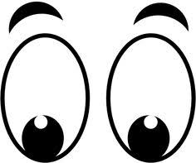
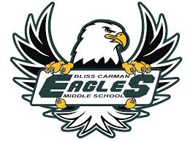
What this looks like…
At BCMS, we are…
 | Classroom/Library | Hallway | Gymnasium | Cafeteria | Outside
Safe | Please:  - Let the teacher know if you need to leave | Please:  - Stay to the right  - Keep your locker door closed and secured  - Walk | Please  - Ask for permission to leave the gym  - Follow the rules of the activities being played | Please:  - Stay in the cafeteria until dismissed  - Walk  - Tech free | Please:  - Ask for permission to go inside  - Respect boundaries  - Play safe and have fun
Respectful | Please:  - Listen when others are speaking  - Keep classroom clean | Please:  - Remove hats, hoodies or toques  - Use inside voice  - Be where you should be | Please  - Remove outdoor footwear before entering  - Keep gym clean  - Accept others ability levels | Please:  - Remain seated  - Indoor voices  - Be welcoming; share the space  - Listen to supervisors/  adults  - No hats/hoods | Please:  - Be kind to others  - Share equipment  - Keep area clean
Responsible | Please:  - Come to class prepared and ready to learn  - Look after your belongings  - Use materials and equipment appropriately | Please:  - Keep hallways clean | Please  - Come to class in athletic clothes.  - Pick up loose equipment | Please:  - Clean up the table and floor  - Recycle | Please:  - Return equipment  - Enter quickly when bell rings

